Major Insect Pests of Corn

1. Corn Seedling Maggot *Atherigona oryzae* Malloch

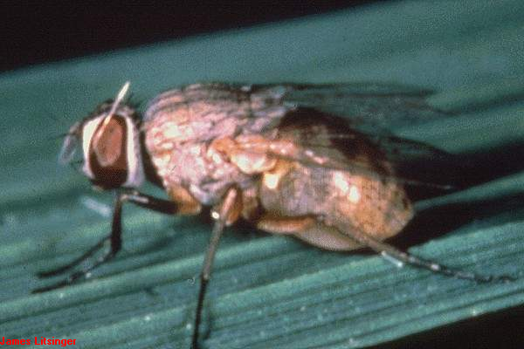

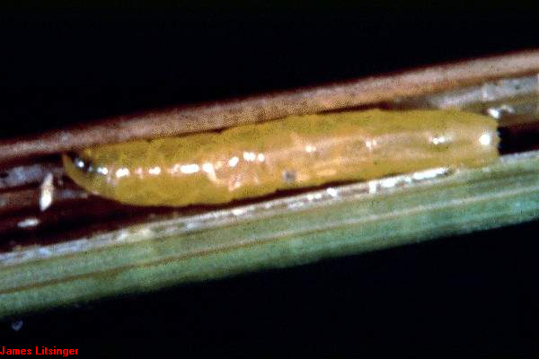

1. White Grub *Leucopholis irrorata* Chev.

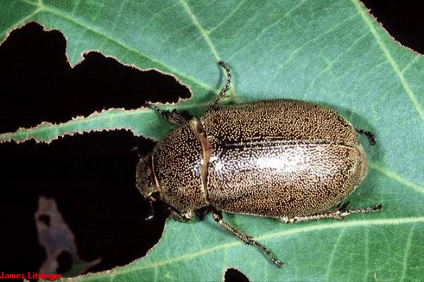

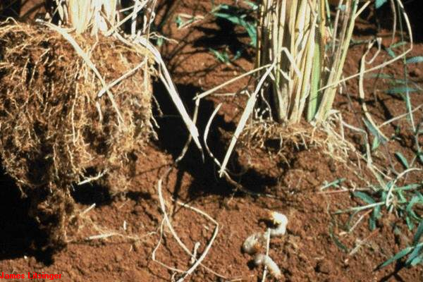

1. Corn Semi-Looper *Chrysodeixis chalcites* Esper

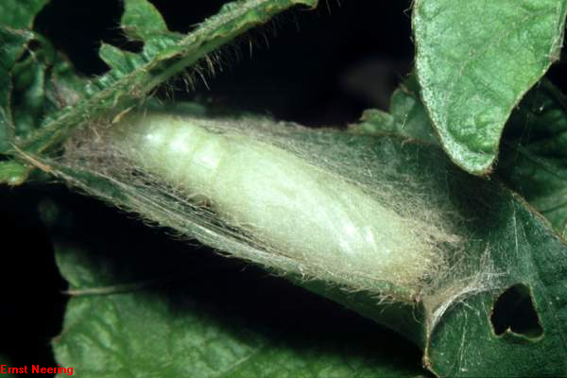

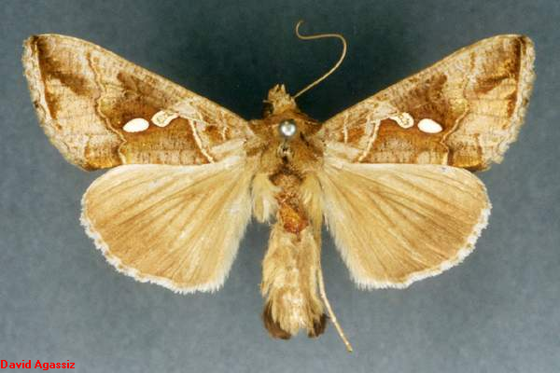

1. Common Cutworm *Spodoptera litura* Fab.

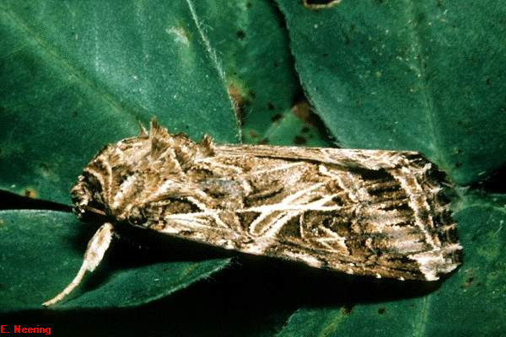

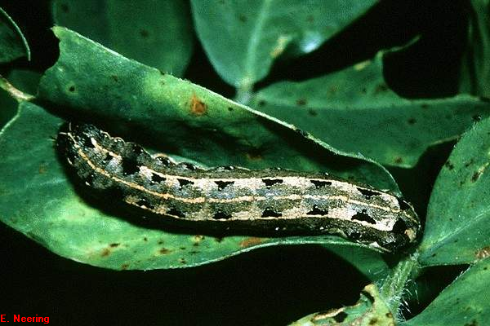

1. True Armyworm *Mythimna separata*

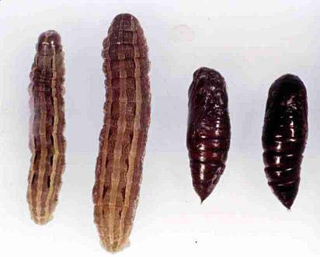

1. Asian Corn Borer *Ostrinia furnacalis* Guenee

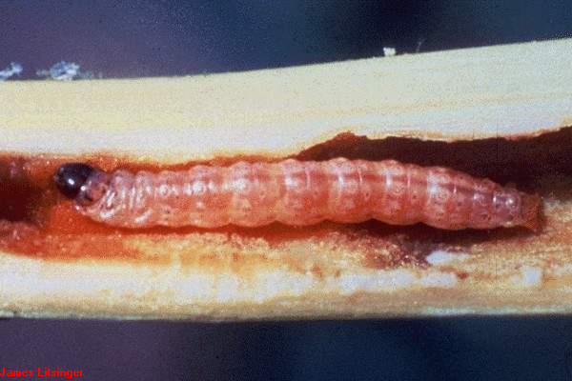

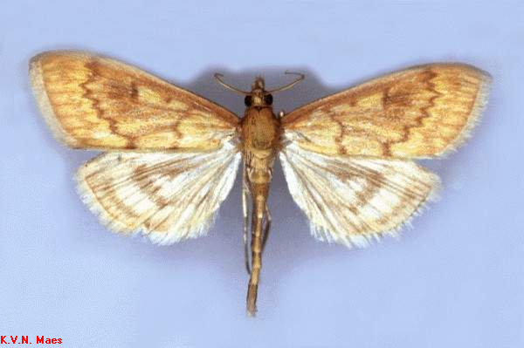

1. Corn Earworm *Helicoverpa armigera* Hubner

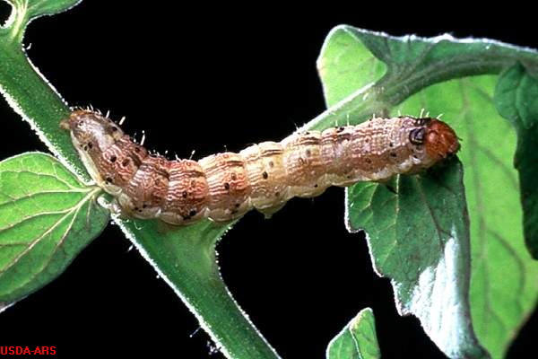

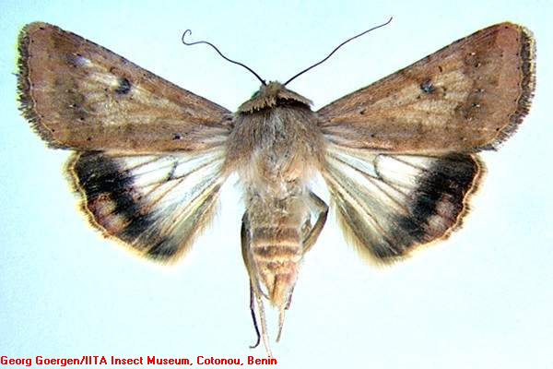

1. Corn Leaf Aphid *Rhopalosiphum maidis* Fitch

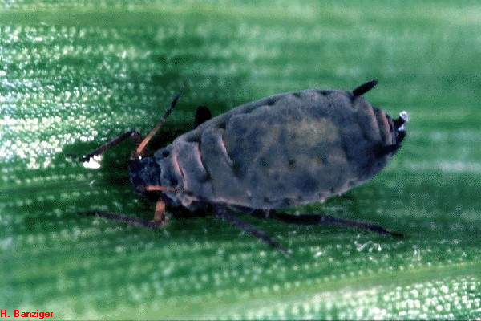

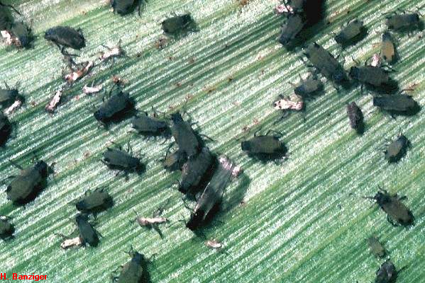

1. Corn Plant Hopper *Stenocranus pacficus* Kirkaldy